Soil fluxes will be sampled using the general static chamber methodology as outlined by Parkin *et. al*., (2003) with a modified protocol as outlined:

**REQUIREMENTS**

* 12V Battery, battery charger and cables
* Temperature Sensors
* Procheck* Meter and Soil Probe
* Data sheets and stationery (pens, pencils, folders and marker pens
* 60 ml Syringes, stop-cocks and needles (0.6 x 25mm)
* Vials
* Chamber lids, clips, vent tubing
* Toolkit and spares
* Stop watches
* GPS
* Umbrellas, boots, panga, raincoat, capes
* Ruler

1. **PREPARATION**
   * + 1. Using the data sheet,

Record the 1) Site ID 2) Ambient Pressure 3) Date 4) Elevation 5)Longitude and 6)Latitude

Record the Start time and the End Time of the collection

* + - 1. Check the chamber lids to ensure that the sealing material, the septum, fan wires and vents are in good condition.

1. Ensure you have enough clips for closing each chamber.
2. Place the lids next to each base together with the clips.
3. Record the height of the base above ground. Take the heights of all sides approximately at the center of the side. As you do this, check the condition of the base correcting/changing where need be and note any incidents.
4. Switch on the temperature sensors attached to the chambers and let them stabilize (about 2 min).
5. Place the battery at a central place and extend the cables so that each lid has a cable. Connect the cables to the lid and power all the fans and ensure that all of them are working.

*Connecting cables:*

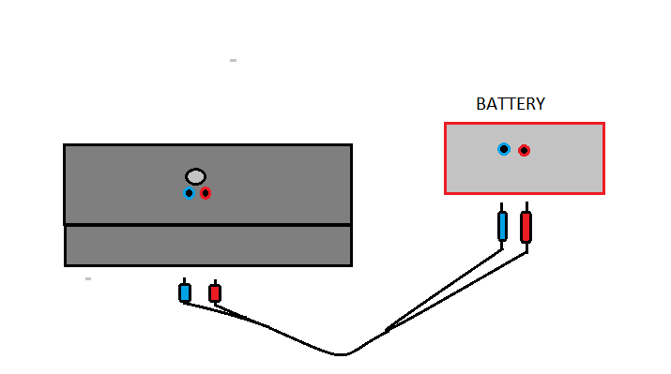

*-Connect one end of each cable to each chamber and the other to the battery.*

*- (Always blue-blue, red-red).*

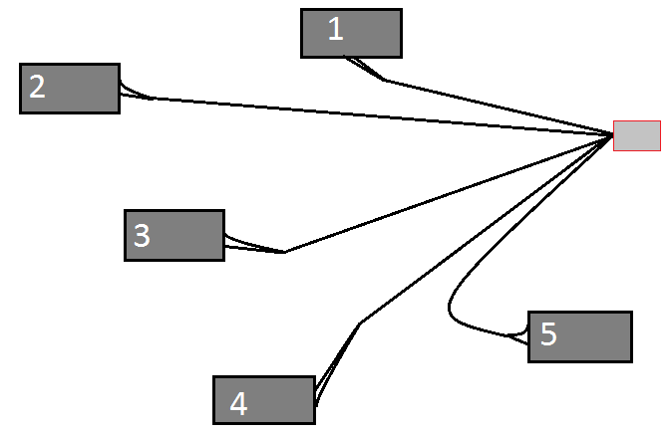

*-Make sure that all fans are working.*

Figure 3: Connecting the cables to the battery and chambers

1. Label the syringe. Flush it with air and place it next to the first chamber.
2. Ensure that the vials are sufficient, in good condition, properly labelled and within easy reach.
3. Environmental condition, Vegetation and soil status.
4. **SAMPLING**
5. Record the time, T1 (0 min) and initial temperature of the chamber as you immediately close the chamber and start the sampling process.

*Closure of chambers:*

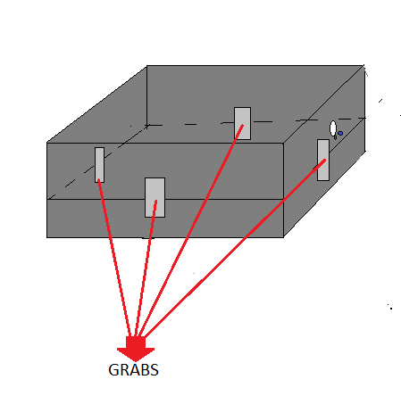

*-Put the lid on the base.*

*-Place the 6 grabs.*

*-Make sure that the system is tight.*

*-Start timer*

*-Begin sampling*

Figure 4: Clipping the chamber lid to the anchor base

1. Use the sampling syringe to take 20 ml of gas from chamber 1 and close the stop-cock (luer-lock).

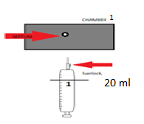 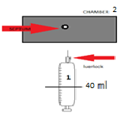 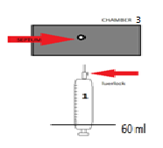

Figure 5: Pooling Method of Gas Sampling to give a composite gas mixture from the three chambers

1. Move immediately to Chamber 2. Repeat step 1 and 2 for the rest of the chambers. You should end up with 60 ml of gas in the syringe.
2. Record the vial number/label in the data sheet. Insert a needle into the vial septum. Insert the sample syringe needle into the same vial septum. Flush the vial up to the 20th ml mark with sample gas and swiftly remove the exhaust needle. Fill the vial with the remaining gas such as to create an overpressure in the vial. Close the stop-cock and pull out the syringe while holding the needle so as not to lose any sample. (The process should be smooth so that there is no interruption/stop/variation of pushing the piston from the start to the finish).
3. Repeat the process for time T2 (15 min), T3 (30 min) and T4 (45 min).
4. **WINDING UP**
5. During sampling for time T4, record the final temperature in the data sheet. Carefully remove the cables from the chamber and open it.
6. Insert the temperature sensor into the soil just outside the chamber for soil temperature and for the rest of the chambers in the plot.
7. Connect the soil probe to the Procheck meter. Switch the meter on and ensure that the soil probe model displayed as well as the units are correct.
8. Carefully insert the probe vertically into the soil outside the chamber (you may need to clear the vegetation so that the probe gets into the soil), press enter and wait for it to stabilize.
9. Record the soil temperature using the Temperature Sensor and use the soil probe to record the soil moisture (m3/m3) and Electrical Conductivity (µS/cm). This should be next to each chamber.
10. Use the temperature sensor to record the ambient temperature taken in the shade.
11. Record all incidents during the sampling process.
12. Gather all instruments and move to the next plot.
13. The vials will then be transported to the lab for analysis within 4 days of sampling.

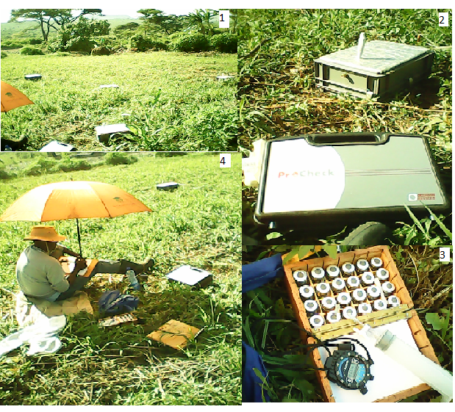

Figure 6: Gas Sampling in progress – 1. The Layout of chambers in the landscape plots; 2. Closed chamber (showing sampling port, pressure vent and temperature sensor) and Procheck* Meter; 3. Box of vials, sampling syringe, needle and stop watch; 4. A determined student “waiting in between times”